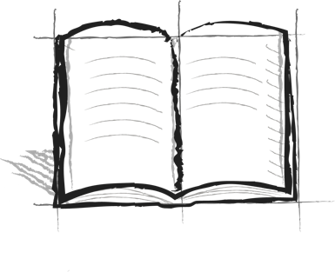

**The Wall Journal Booster**

**9 – Self - Reflection**

Each of the steps on the wall include a question for you to ask yourself. These questions help you to remember if you are taking the right steps to stay on top of the wall.

Are you taking the steps to get on top of the wall?

If so, what differences have you observed at home?

What differences have you observed at school?

What differences have you observed with your peers?

How does climbing the steps and achieving the “Big View” give you endless options?