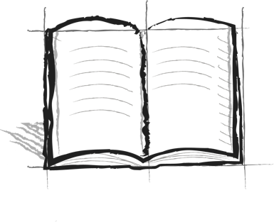

**The Wall Journal Booster**

**7 - Failure**

What does it mean when someone says, “If you fail to plan, you plan to fail!”?

Why is planning an important part of seeing over the wall?