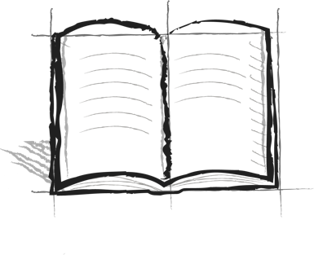

**The Wall Journal Booster**

**6 - Perspective**

What does “perspective” mean? How does your perspective change as you climb the wall?