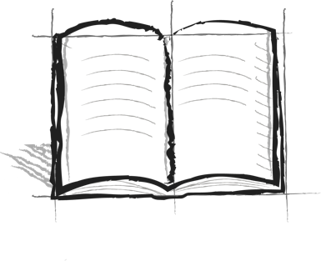

**The Wall Journal Booster**

**3 – Atop the Wall**

How do you know if you are on top of the wall? If you climb the wall, what will you be able to see?