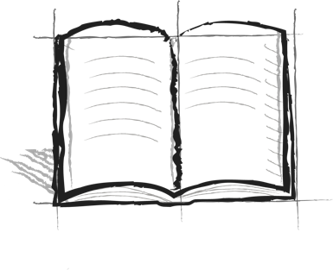

**The Wall Journal Booster**

**2 – Steps**

What are some steps you are taking to see over the Wall?