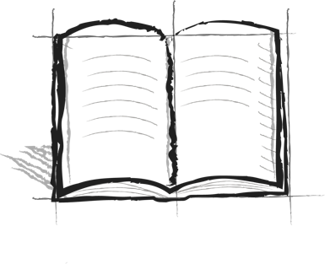

**The Wall Journal Booster**

**1 – The Wall**

What does the Wall represent in The Wall metaphor? In what way does it limit your view?