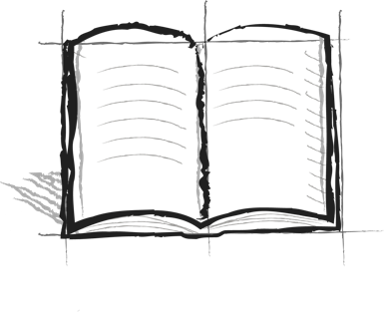**Reality Ride Journal**

**Booster 9 – Examples**

Can you think of a character in a story, book, or show that is always getting into trouble? Why do you think they are stuck in the loop? What could help them to get out of the loop?