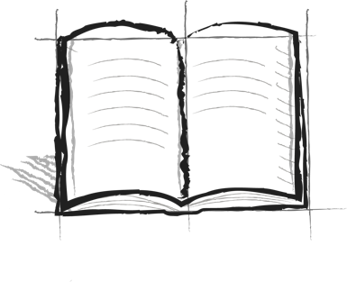**Reality Ride Journal**

**Booster 4 – Own Example**

Tell about a time when you did something that was harder but worth it. What did you do to stick with it? How did you feel when you were done?