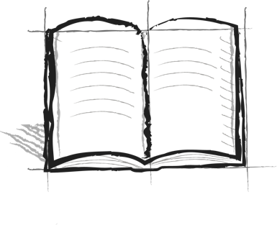

**Jumping Hurdles Journal**

**Booster 6 – Starting Line**

When you run a hurdles race there is a starting line. What does it mean to start where you are and move forward?