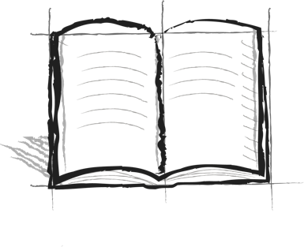

**Jumping Hurdles Journal**

**Booster 11 – Self Reflection**

Perseverance – “To continue doing something despite obstacles, difficulties, and set-backs.”

What does that definition mean to you in your own words? What is an example of your own perseverance?

What does it mean to start where you are and move forward?

What are some hurdles that you have already jumped over in your life?