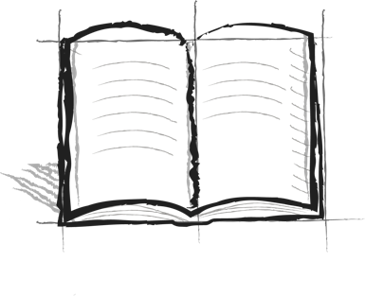

**Jumping Hurdles Journal**

**Booster 1 – Hurdles**

What are hurdles?

Who has hurdles?

Why is it important to learn to jump over hurdles?