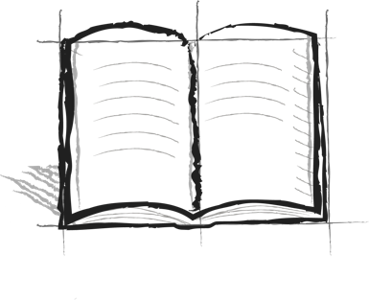

**DTE Journal Booster 8 – Time**

What is something you have spent a lot of time doing in the past? What things do you spend the most of your time doing now?

What do you think you will spend a lot of your time doing in the future?