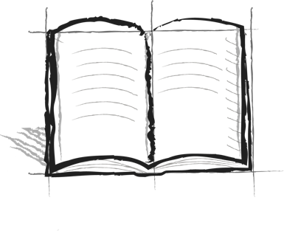

**DTE Journal Booster 2 : Schedule**

Write a timeline for how you would spend a typical day. (Ex. 8:00 wake up, get dressed 8:30 eat breakfast, etc.)

What parts of your day require the most desire, time, and effort to complete?